Flask & MongoDB

Task 1: JSON API Route
Code: data.json
[
{
"name": "Karthik",
"role": "Cloud Engineer"
},
{
"name": "Rahul",
"role": "DevOps Engineer"
},
{
"name": "Priya",
"role": "Python Developer"
}
]
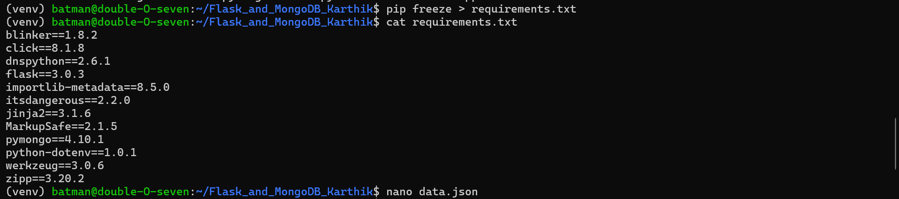
Create the Flask application
Code: app.py
from flask import Flask, jsonify, render_template, request, redirect, url_for
from pymongo import MongoClient
from dotenv import load_dotenv
import json
import os

load_dotenv()

app = Flask(__name__)

# MongoDB Atlas connection
MONGO_URI = os.getenv("MONGO_URI")

client = MongoClient(MONGO_URI)
db = client["flask_assignment"]
collection = db["users"]

# Task 1: JSON API Route
@app.route("/api")
def api():
try:
with open("data.json", "r") as file:
data = json.load(file)

return jsonify(data)

except Exception as e:
return jsonify({"error": str(e)}), 500

# Task 2: Frontend Form
@app.route("/", methods=["GET", "POST"])
def home():
error = None

if request.method == "POST":
try:
name = request.form.get("name")
email = request.form.get("email")

if not name or not email:
raise ValueError("Name and email are required.")

user_data = {
"name": name,
"email": email
}

collection.insert_one(user_data)

return redirect(url_for("success"))

except Exception as e:
error = str(e)

return render_template("index.html", error=error)

# Success page
@app.route("/success")
def success():
return render_template("success.html")

if __name__ == "__main__":
app.run(host="0.0.0.0", port=5000, debug=True)

Explanation:
/api:
http://localhost:5000/api
reads:
data.json
and returns it as JSON.
The / route displays the frontend form.
When the form is submitted:

Form
↓
Flask
↓
MongoDB Atlas
↓
Success → /success
If something goes wrong, the error is displayed on the same form page

Create the frontend:
Code: index.html
<!DOCTYPE html>
<html>
<head>
<title>Flask MongoDB Form</title>
</head>

<body>

<h1>Submit Your Details</h1>

{% if error %}
<p style="color: red;">
Error: {{ error }}
</p>
{% endif %}

<form method="POST">

<label>Name:</label>
<input type="text" name="name" required>

<br><br>

<label>Email:</label>
<input type="email" name="email" required>

<br><br>

<button type="submit">Submit</button>

</form>

</body>
</html>

Create success page:
Code: success.html
<!DOCTYPE html>
<html>
<head>
<title>Success</title>
</head>

<body>

<h1>Data submitted successfully</h1>

<a href="/">Submit another response</a>

</body>
</html>

Run the application
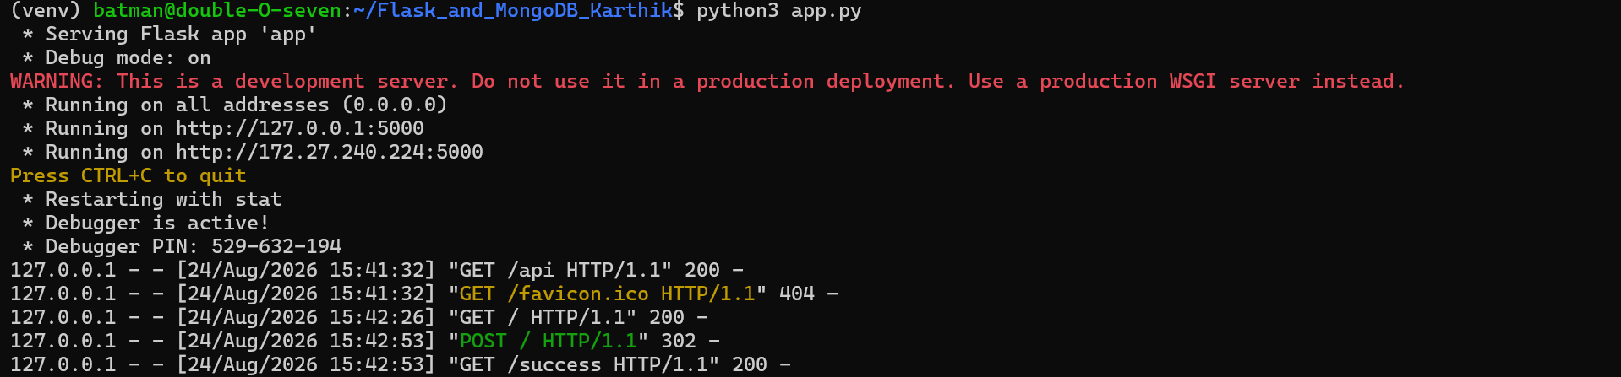
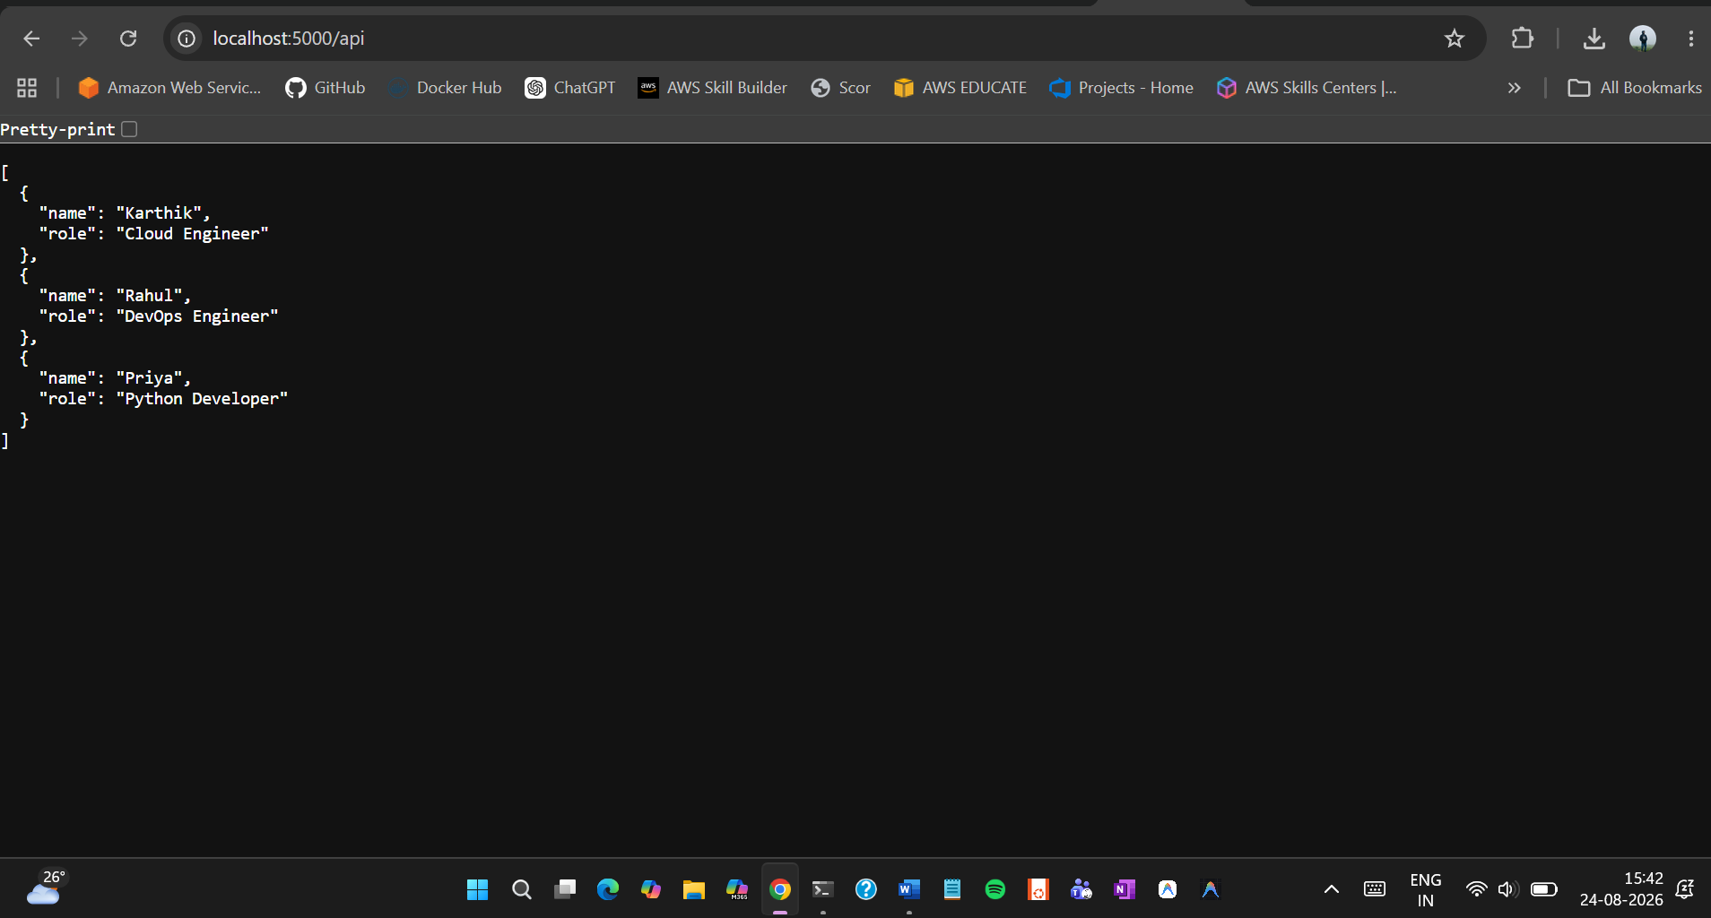

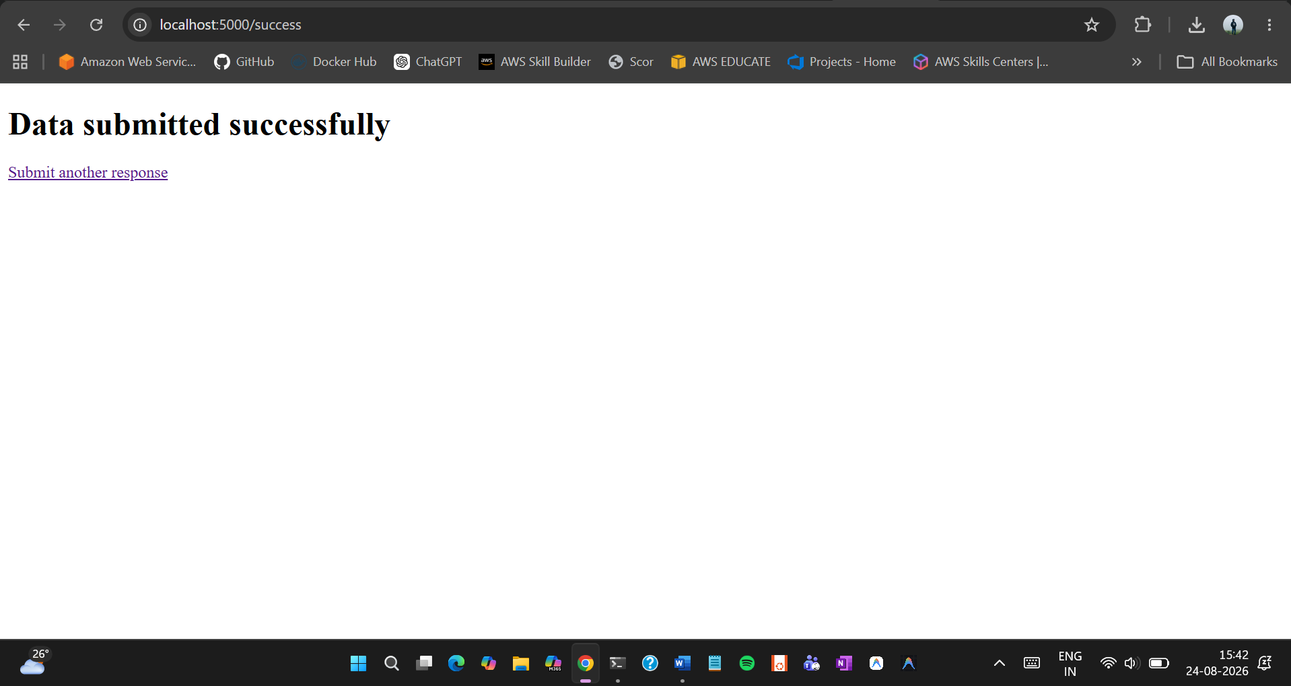
Data in MongoDB Atlas:
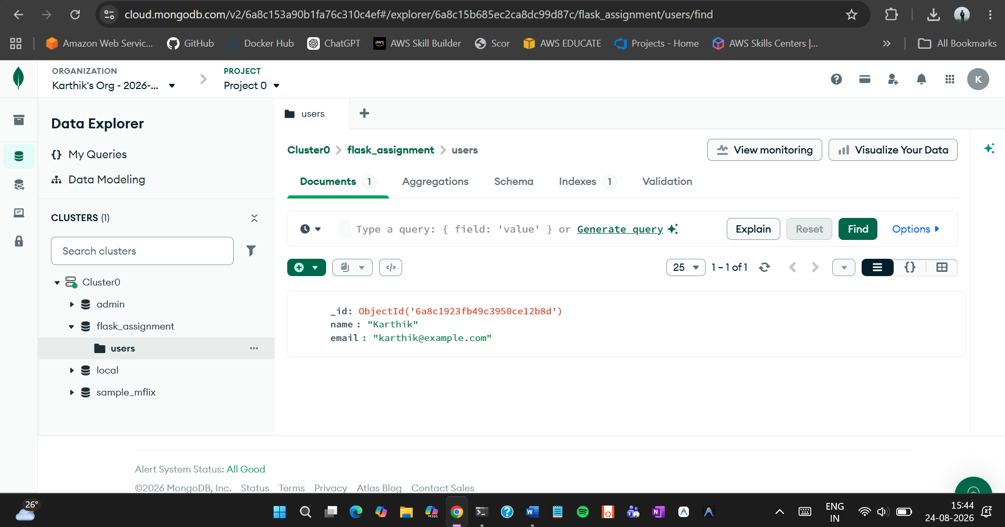

Test the error handling:
1. Stopped the application
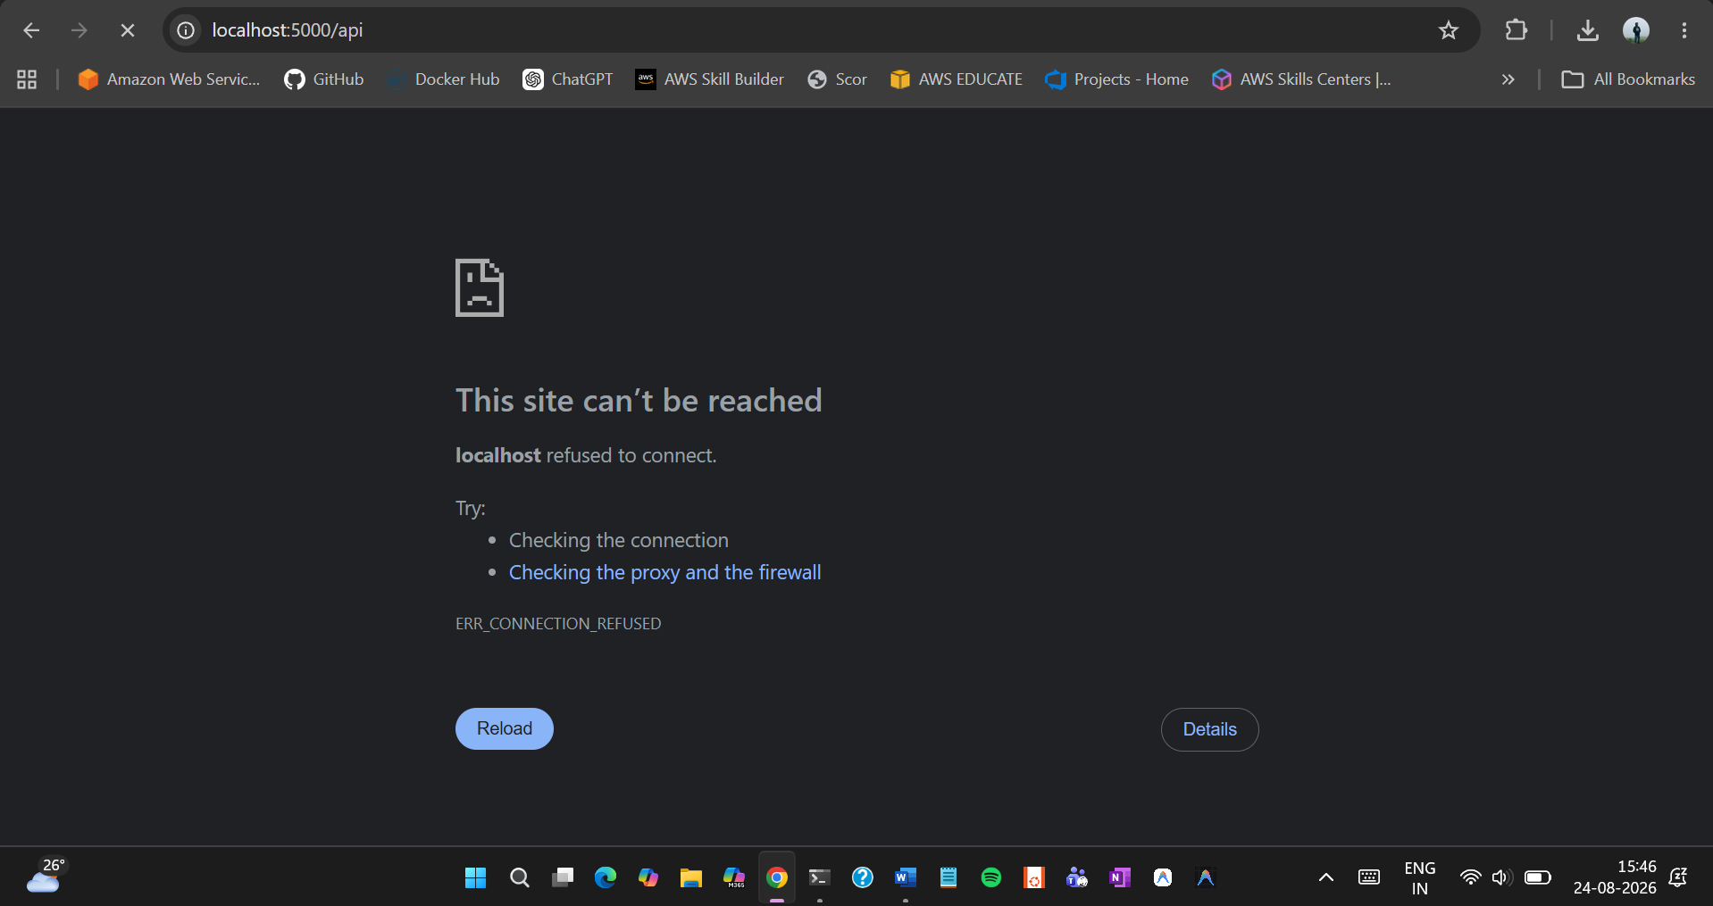

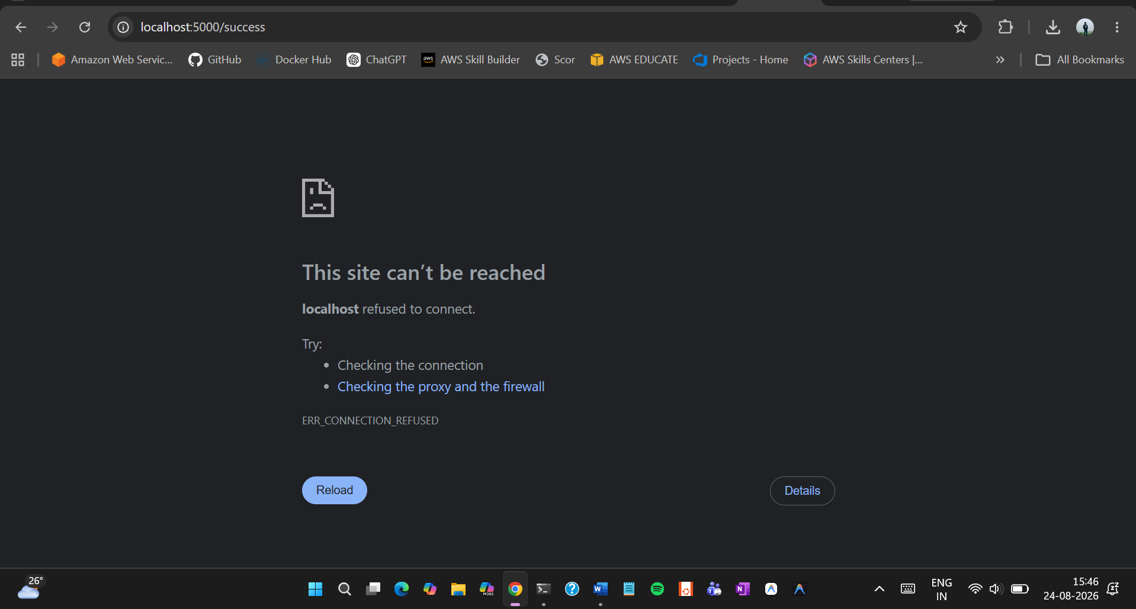
2. Temporarily changed .env
